# Software Engineering Group Project

# Meeting Minutes

Date: Jan-15th, 2019

1. 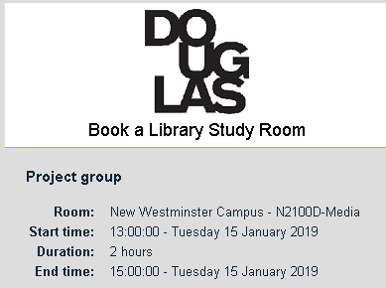Agenda

Regular meeting for group project: discussion and divide the roles of the project proposal for CSIS 3275, Software Engineering course at 13:00 on 15th at location.

1. Attendants

Daniel Ahn (Seongku Ahn), Ankit, Twinkle

1. Last issues
   1. Review the project proposal documents given by instructor.
   2. Which types of program will be implemented?   
      Web application based on Java because it should interact with 2 external components
   3. Brainstorming for our group project.
2. Open issues
   1. Prepare the project proposal:   
      1) cover page: problem/solution   
      2) scope: role based movie information system  
      3) group dynamics  
      4) use cases (8 use cases, at least 4 objects): customer (2), DBA (2), user manager (2), administrator (2)  
      5) toolset: JS, Java, Spring, MySQL + Git, Hibernate, Junit, Selenium, Jenkins   
      6) schedule  
      7) meeting minutes
   2. R&R (Role and Responsibilities):   
      1) overall project scheduling and management:   
       leader (Daniel), DBA (Ankit), user management (Twinkle)  
      2) documentation and printing (everybody)  
      3) reservation room and meeting minutes (everybody)  
      4) development of components:   
       - framework, menu, basic design (Daniel)  
       - login/user registration (Twinkle)  
       - update movies: movie data with SQL (Ankit)  
       - role management (Daniel)  
       - test with Junit and Selenium (everybody)
3. Next steps
   1. The introduction of project environment: platform and toolset
   2. How to code and build the application. Uploading the code to Github.
   3. Details of each component
4. Submitter

Minutes submitted by: Daniel Ahn (Seongku Ahn)